Natural Flood Management Project Officer, (Buckingham Area)
A Project run by the River Thame Conservation Trust (RTCT), in Partnership with The Upper & Bedford Ouse Catchment Partnership (U&BOCP) - (Buckingham Area)

Project Outline and Management
This is a 3-year project to design, plan and deliver a series of flood mitigation measures designed to protect properties in Buckingham Town, which are at medium risk of flooding. The design will incorporate a suite of Natural Flood Management techniques. This project will be managed by the River Thame Conservation Trust (RTCT) (The Employer), in partnership with The Upper & Bedford Ouse Catchment Partnership (U&BOCP).
The River Thame Conservation Trust is a small charity, based in Headington, Oxford, dedicated to conserving, protecting and rehabilitating the River Thame and its catchment and nearby rivers and their catchments. The Trust also promotes education and understanding of rivers, their catchments and associated freshwater habitats.

The Charity runs a number of practical conservation and education projects throughout the area funded by the Thames Water, The Environment Agency and other donors. The Trust also acts as the joint host for the River Thame Catchment Partnership and works closely with other catchment partnerships, particularly within the River Thames catchment and the Upper Ouse and Bedford Catchment. The project will also be overseen by a steering group made up of representatives from RTCT the Upper Ouse Catchment Partnership, the Environment Agency, AVDC and Bucks CC.

Project Area

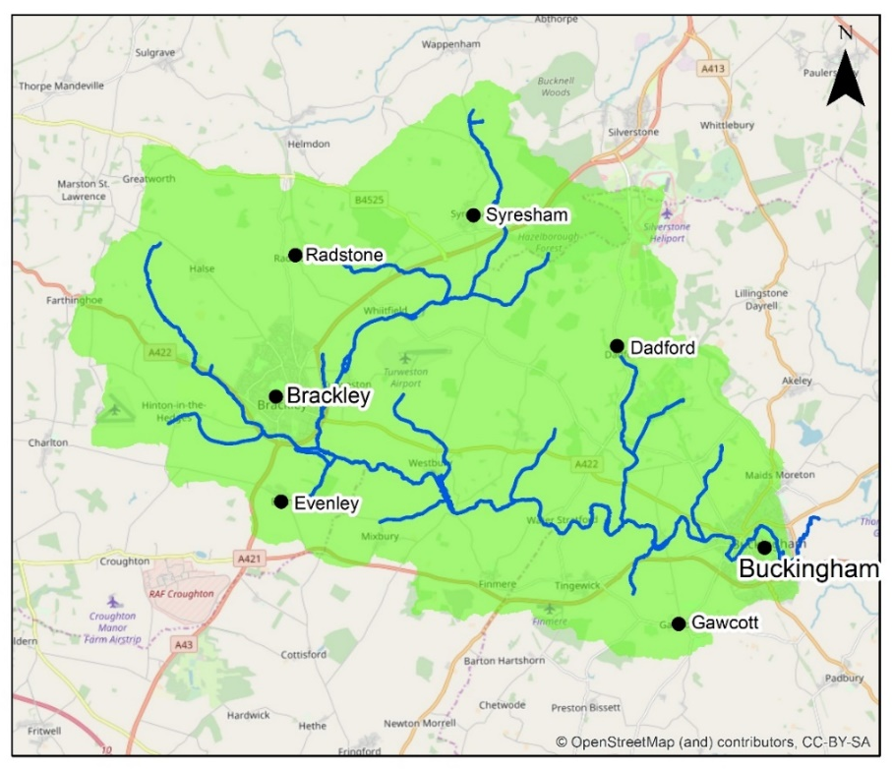
The project area involves the Upper Ouse catchment area from Buckingham upstream

The main tributaries are shown (including Hinton Stream, Radstone Brook, Stowe Brook, Syresham Stream) along with several areas of population for reference.

Project Detail

- You will Investigate and implement a series of NFM measures* in the catchment upstream of Buckingham that will contribute to a lowering of future flood risk.
- This will be achieved by production and implementation of a work plan of priority measures to be implemented with landowners and partners in and around Buckingham.
- Work will involve:
  - Working with specialist contractors to carry out flood and NFM opportunity modelling for the upper catchment.
  - Engaging regularly with stakeholders, partners, landowners and communities to identify and develop opportunities.
  - Surveying sites to identify NFM opportunities.
  - Prioritization of areas and sites for interventions.
  - Leading and overseeing delivery of NFM measures on the ground through a combination of contractors, volunteers, landowners/managers or by yourself.
  - The design and implementation of a monitoring programme to measure effectiveness of the NFM measures.
*NFM measures may include (but are not limited to) the creation of runoff attenuation features, e.g. ponds; increasing the roughness of surfaces, e.g. by planting woodland; de-compacting soils to increase infiltration; altering land management practices to reduce surface water runoff; reconnecting a river with its floodplain; installing woody material in and around river channels; and re-meandering rivers.

