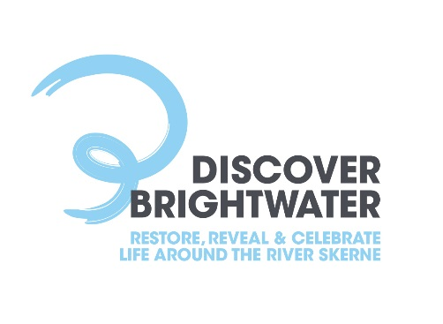

INVITATION TO TENDER
Holdforth Bridge to Fishburn River Restoration
ITT 1

Tender Manager – Dafydd Jones
Tel: 01325 327342
Email: djones@durhamwt.co.uk
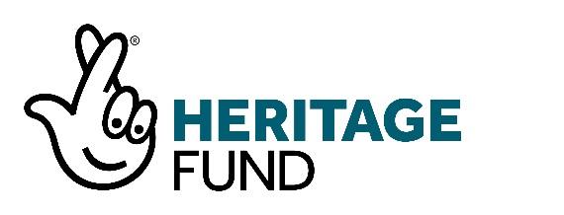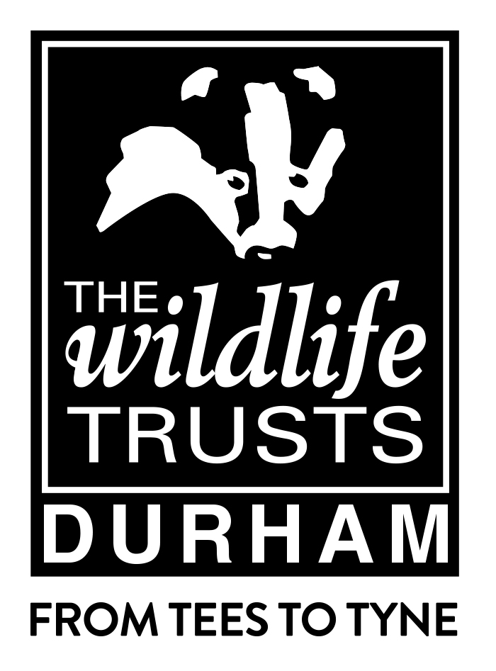

Contents

Introduction 3
The Project and Vision 3
Durham Wildlife Trust and the Discover Brightwater Landscape Partnership 3
The Bright Water Landscape Partnership 4
Invitation to Tender 4
The Heritage Lottery Fund 4
Context and Outline of Work Required 4
Milestones and Deliverables of the Contract 5
ITT and Contract Timescales 6
Payment 7
Appendices and Design Notes 7
Contractor Specification 8
Tenders and deadline for submission 9
Further information 9
Assessment of Tenders 9
Conditions of Tender 10
Canvassing 10
Terms and Conditions 11

Introduction

The Discover Brightwater Landscape Partnership, lead partner Durham Wildlife Trust, seeks a contractor to deliver in river improvements to the River Skerne initially for the works outlined below, but the partnership will be using the cost models and approach provided by the winning tender as the basis for potential additional work.
This specification sets out those initial works identified to deliver in river improvements to the River Skerne between Holdforth Bridge and Fishburn for the Durham Wildlife Trust on behalf of the National Lottery Heritage Fund (NLHF) funded Discover Brightwater Landscape Partnership.
Discover Brightwater covers an area of approximately 200km2 within lowland County Durham and Darlington, focusing on the River Skerne catchment from Hurworth Burn reservoir to South Park in Darlington. The project area includes the communities of Newton Aycliffe, Sedgefield, Bishop Middleham, Fishburn, Heighington, Brafferton, Barmpton and Darlington. The project’s Delivery Phase runs from July 2018-December 2022.

The Project and Vision

Over the last two hundred years, the landscape of this area has been significantly altered, including the River Skerne itself. There is an important history of globally significant innovation occurring within the area that influenced both the agricultural and industrial revolutions. However, there is a general lack of awareness and appreciation of this local heritage. Many people are not well connected to the landscape on their doorstep. There are physical barriers to access, with the A1 and the East Coast main line bisecting the landscape and intellectual barriers with limited information available on what the landscape has to offer.
The vision of the Bright Water Landscape Partnership is to reveal a heritage of change and innovation, supporting opportunities to enhance and enjoy the natural, built and farmed landscape, realising gifts for now and the future, raising aspirations and inspiring communities. To achieve this vision the partnership will aim to:
Work to reveal the landscape of the past, showing how it has been shaped by man (human activity) over thousands of years
- Work with landowners, local communities and other partners to reveal, restore and enhance key elements of the natural, built and cultural landscape
- Enable more people to access the heritage of the landscape, helping to improve health and well-being
- Highlight the cultural heritage of the area, a story of wide-ranging innovation that has shaped the modern world –which includes both the birth of the railways and cattle breeding programmes which produced the magnificent Durham Ox
- Provide opportunities for learning and training, ensuring the heritage of the area is better known and conserved
- Provide new opportunities for businesses, making them more resilient in the future.

Durham Wildlife Trust and the Discover Brightwater Landscape Partnership
Durham Wildlife Trust was founded in 1971 to promote nature conservation and enable local communities to increase their enjoyment and understanding of their natural heritage. The Trust manages nature reserves across County Durham, Darlington, Gateshead, South Tyneside and Sunderland and operates two Visitor Centres. It is currently delivering several nature conservation projects and providing a regular programme of education and volunteering opportunities for thousands of children and adults every year.
The Trust is a membership organisation and has over 240 volunteers. Its reserves are popular with a cross-section of society from wildlife enthusiasts to families and school children. The Trust produces an annual business plan, which identifies activities and strategies to deliver its core objects under three main headings:
- Providing Environmental Education
- Conservation
- Managing Trust Nature Reserves

The Discover Brightwater Landscape Partnership
The Bright Water Landscape Partnership comprises: Durham Wildlife Trust, the Environment Agency, Groundwork North East, Durham County Council, Darlington Borough Council, Durham County Local Access Forum, Tees Rivers Trust, Architectural and Archaeological Society of Durham, Highways Agency, Northumbrian Water and community representatives. The Partnership works closely with a range of regional bodies including Visit Durham, Natural England, Historic England and the North East England Nature Partnership.

Invitation to Tender
Durham Wildlife Trust (DWT) as lead (and contracting) partner for the Discover Brightwater Landscape Partnership invites tenders for the works specified in this document.
- DWT is seeking to appoint a contractor to deliver improvements to the River Skerne as outlined below together initially, and potential other areas of future improvement identified along the river, with the engagement, recruitment, training and deployment of local volunteers.
- The contractor will also need to work in partnership with the Discover Brightwater Team and independent Evaluator to demonstrate the impact, effectiveness and value of the work carried out.
- The contractor will need to be able to demonstrate appropriate provision in place to act as Principal Designer and Contractor with regards to CDM 2015 regulations.
- Tenderers are advised to read the documents carefully to ensure that they are familiar with the nature and content of their obligations if their tender is accepted.

Tenderers can clarify any points of doubt or difficulty by contacting:
Dafydd Jones, Natural Environment & Access Project Coordinator, Tel: 01325 327342
Email: djones@durhamwt.co.uk

The National Lottery Heritage Fund
The National Lottery Heritage Fund [NLHF] is the principal funder of the Discover Brightwater Landscape project. NLHF places a strong emphasis on the evaluation of Landscape Partnerships. Its guidance (available on the NLHF website) recommends that evaluation:
- Is built into a scheme from the start and involves regular reviews;
- The successful contractor will work with the Delivery Manager to support the Delivery Team and Partner organisations to enable them all to carry out their role(s) in the monitoring and evaluation process.

Context and Outline of Work Required

This project will improve a 1.5km stretch of the River Skerne and associated riparian habitat. See Appendix 2 – Discover Brightwater – River Skerne habitat improvement works – Fishburn to Holdforth Bridge.

Work to improve the Skerne in County Durham in recent decades has included in-channel works to allow fish such as dace and brown trout to move upstream from the Tees. The presence of fish and invertebrates has seen the return of kingfisher, otter and dippers to the river. Although further improvements remain to be made, the Skerne has moved back into focus as a recreational amenity and economic asset for Darlington town. However, further other areas along the Skerne continue to suffer from multiple issues due to a range of historical industrial, agricultural and geological features.
Problems include: canalisation, low flow and sediment issues and fragmented habitat. Long stretches of the river are simply too choked with weed to allow free movement of fish. This has resulted in occasional pools occupied by large fish and juvenile fish in this habitat have a reduced chance of survival due to predation by larger individuals. Reed growth prevents juvenile fish to moving to alternative habitat. The efforts to improve fish passage between the Tees and Skerne are not reaching their full potential as weed growth prevent species such as trout reaching the upper reaches of the Skerne.
This project will work over a 1.5km stretch of the river to mitigate and resolve some of these problems and provide this section of the river with a more natural morphology by allowing normal flows so that natural processes are restored i.e. reduced sedimentation.

- The proposed work will work both instream and on the bankside and as a key part of the project will provide volunteers with an excellent opportunity to learn about river ecology as well as practical tool-handling techniques. It will also work closely with landowners to ensure that they are involved with the design and placement of interventions and understand how the measures will improve flow and channel morphology. Ensuring that the standard of work is completed to their satisfaction will encourage adoption and long term maintenance of the improved channel.

Measures may include, but are not limited to:
- Installation of Flow deflectors – made from sections of larch or other suitable natural material to be agreed and anchored to the riverbed. These deflect and concentrate flow, oxygenate the water and clean gravels and keep sediment moving more freely through the system.

- Channel narrowing –creating a channel within a channel using bundles of birch brash or other suitable natural material anchored into place with appropriate stakes to speed up flow and add depth to the channel. Successfully introduced, this should reduce weed growth, help oxygenate water and clean gravels. Additionally, the gaps and holes in the brash bundles provide good habitat for juvenile fish as well as invertebrates. Bundles will be made from brash material gathered from woodland and assembled on site by volunteers guided by a project officer. This will also give volunteers an opportunity to learn about woodland management and coppicing techniques.

- Tree thinning and planting – the optimum tree cover for a river is approximately 40% shading with a mosaic pattern. This provides enough sunlight to encourage some weed growth whilst also keeping the river at an ambient temperature. The project will thin the canopy of overshaded areas and plant trees such as alder and willow at sites where all tree cover has been removed. Tree cover being preferred on south banks where available, recognising the north south direction of the river in most places. The successful contractor will again work with volunteers to deliver this aspect of the work.

Milestones and Deliverables of the Contract

Outputs
There are a number of outputs which this project is required to achieve by our funders:
Outputs for Environment and Heritage:
- Better Managed and in measurably better condition – the contractor will work with the Discover Brightwater team to decide on the baseline and outcome evaluation method and metrics.
- 1.5 km of the River Skerne will benefit from improvements that include the mitigation of previous channelization, sediment and flow issues.

Outputs for people:

A minimum of 10 people will have been trained in river restoration skills and 200 volunteer days of support delivered

Outputs for communities

- The adverse environmental impact of previous over-engineering of river Skerne and high levels of pollution will be reversed.

- More people and a wider range of people will have engaged with Bright Water’s natural heritage

- This part of our area will become a better place to live and visit as this long stretch of the Skerne is restored to its more picturesque original condition.

Outcomes for Heritage

- A 1.5km stretch of the river Skerne will be restored to a much-improved condition.

Outcomes for communities
- This area will become a better place to live and visit because the water quality and habitats will be improved, leading to more people visiting more often

Engagement and Permissions
The successful tenderer will need to provide a detailed plan and outline their approach to carry out this engagement. This will include steps and activities anticipated to obtain all relevant permissions including landowner/tenant permissions, Flood Risk Activity Environmental permits and any required planning permissions in relation to Skerne river restoration – Fishburn to Holdforth Bridge.

Reporting Arrangements and Fees
The appointed contractor will report to Dafydd Jones, Natural Environment and Access Projects Coordinator, Discover Brightwater Landscape Partnership, Flexspace Unit 28, Durham Way South, Newton Aycliffe Business Park, Newton Aycliffe, DL5 6ZF.

Payment for the works shall be paid on production of detailed invoices itemising all of the work carried out and the amount due at each stage.

ITT and Contract Timescales
Indicator | Date
ITT issued | Thursday 18th August
Opportunity for site visit | Wednesday 29th September 2021 or Thursday 30th September 2021, 11.00am starting at Fishburn, County Durham. Contractors must confirm their attendance and meeting locations will be sent subsequently.  Other dates and times, within the contract timescales, for site visits can be requested with the tender manager if made with at least 7 days’ notice, but cannot be guaranteed.
Deadline for submission of tender | 5.00pm Wednesday 6th October 2021
Contract awarded | ASAP after the deadline and following Discover Brightwater Partnership tender evaluation and due diligence – target date Thursday 7th October 2021.
Commencement of Contract | September 2021
Completion of Work, final report and final invoice | Not later than 2nd September 2022
This timetable is indicative only. While Durham Wildlife Trust does not intend to depart from the timetable, it reserves the right to do so at any time. It also acknowledges the potential impact of adverse weather conditions on the project timeline.

Copyright/Intellectual Property
Title in all work shall pass to Durham Wildlife Trust on payment for that work completed. The risk in any works shall remain with the contractor until delivery is confirmed, accepted and payment made.

Payment
1st Interim payment will be made after initial EIAs, permissions, plans, designs have been agreed and/or obtained (circa 30% of total budget)
2nd Interim payment will be made on procurement of materials (c40%)
Final payment will be made on successful completion, sign off of work by DWT and receipt of photographic evidence pack (c30%)
Bidder’s proposals for this Quotation must be inclusive of all expenses.
All prices submitted must include VAT where applicable.
The total payable will be no greater than the total amount on the attached Bill of Quantities and included in the ITT Schedule 2 Tender Response Document.

Appendices and Design Notes

Bill of Quantities
For completion and submission with the tender. Please note that all tabs must be completed – Appendix 3 – Fishburn to Holdforth Bridge, Bill of Quantities, Reaches & Interventions.

Pre-construction Health and Safety Information
As well as providing information for this tender this will form the basis of the equivalent document to be submitted as part of the final contract documents.

Pre-construction Environmental Information
The contract will require appropriate contemporary Protected Species surveys (including but not limited to otters, water voles and potentially bats relevant to any tree work) utilising advice of a competent Ecologist. The presence of any Protected Species would require appropriate mitigation to be submitted as part of an application for a Protected Species Licence to Natural England. The cost of any surveys and EIA work must be included within the cost of the tender.
The contract requires an Environmental Plan that sets out how the contract will be delivered without causing pollution or environmental harm. Potential sources of pollution include silt, oils or impacts on dissolved oxygen from sediment disturbance. The plan must also identify how bio-security risks will be mitigated at a minimum employing Check – Clean – Dry measures. For more information see http://www.nonnativespecies.org/checkcleandry/

Designs for the restoration of river stretches should be guided by the River Restoration centre Manual of River Restoration Techniques which can be found at

http://www.therrc.co.uk/manual-river-restoration-techniques

In particular restoration examples 1.1 – River Cole, 1.2 – River Cole, 1.4 – River Skerne and 7.2 – River Thames, which can be found at
New meandering channel through open fields
New channel meandering either side of existing channel
New meanders to one side of existing channel
Floodplain wetland mosaic
River restoration designs alongside cultivated land will take account of higher tier Countryside Stewardship grant option SW4, the creation of a 12m to 24m watercourse buffer strip on cultivated land.

The successful bidder will have access to a number of detailed Environment Agency documentation including:
- 2016 River geometry survey
Channel Survey data in ISIS format. Data shall be supplied in EACSD V3.2 format and include CES1 and CES2 data.
- 2002 ISIS Skerne model outputs
- Flood Risk outlines based on J Flow
- LIDAR data is available at https://data.gov.uk/data/search?q=lidar

Contractor Specification
The successful applicant, which may be an individual, company or consortium working to a lead applicant will be expected to demonstrate substantial expertise in delivering similar work. Two referees of similar projects should be provided for the Trust to obtain references.

Tenders and deadline for submission
Those submitting a tender should respond with the following:
- Relevant experience and qualifications including brief CV(s )of key people leading and working on the project including those able to perform the appropriate role of Principal Designer for CDM purposes
- Proposed approach to carrying out the work, including methodology, work programme and reporting arrangements to cover the river work, engagement, training and management of volunteers and evaluation. This should include a detailed plan of work and a timetable showing key milestones and deliverables including numbers and types of intervention and locations. It will also outline what and how necessary permissions will be obtained.
- An Environmental plan detailing the bidder’s approach, likely risks and impacts and mitigation activities
- Proposed fee basis
- Analysis of fee into number of days’ work and daily rate, materials, expenses and other costs, VAT if applicable
- Complete ITT Schedule 2 – Tender Response Document including completed Section A pro-formas for all bidding organisations(if bidding as a partnership of consortium)
- Completed and signed Section J– Form of Tender
- Completed and Signed Section K– Non Collusive Tendering Certificate
- Completed Bill of Quantities (Appendix 3)
- Environmental Policy and evidence of how your organisation is progressively working towards reducing its carbon footprint and making a positive impact on the environment
- Equal Opportunities statement
- Names and details of two site references/referees
The deadline for hard copy or signed and scanned electronic submissions is 5.00pm Wednesday 6th October 2021. We will acknowledge receipt of all tenders as soon as practically possible after we have received them.

Further information
Further information can be provided or an informal telephone discussion can be arranged with Dafydd Jones, Natural Environment & Access Projects Coordinator Tel:01325 327342

Assessment of Tenders
The tenders will be assessed for value for money, by comparison of the number of days’ activity proposed for the project budget or daily rate, and an assessment of quality based on previous experience of delivering similar work, and approach and methodology proposed for this project.

The balance of assessment will be:
Quality of application and ideas 20%
Price and Value for money – based on delivery day rate(s) and number of days 50%
Previous relevant experience, qualifications and references 20%
Project timetable, plan and approach to working with volunteers and innovative evaluation 10%

Tenders will be assessed using the information provided and we plan to confirm the successful bidder by Thursday 7th October 2021. The initial project meeting will be held as soon as possible after this date.

Conditions of Tender

Preparation of tender
Tenderers must obtain for themselves, at their own responsibility and expense, all information they deem necessary for the preparation of their tenders.
Great care should be taken in the preparation of this tender because, on receipt, Durham Wildlife Trust will not entertain any request for alteration on the grounds that an error has been made.

Canvassing
Any Tenderer who directly or indirectly canvasses any person acting as a Trustee, committee member or member of staff of Durham Wildlife Trust or of the Bright Water Partnership concerning the award of the contract for the provision of services will be disqualified.
Confidentiality of Tender Information and Documents
All information supplied by Durham Wildlife Trust in connection with this Invitation to Tender shall be regarded as confidential to Durham Wildlife Trust.
Collusive Tendering
Any Tenderer who:
- fixes or adjusts the work to be provided for in their Tender by or in accordance with any agreement or arrangement with any other person; or
- communicates to any person other than Durham Wildlife Trust the details of their proposed Tender (except where such disclosure is made in confidence in order to obtain a quotation necessary for the preparation of the tender for insurance or a contract guarantee bond); or
- enters into any agreement or arrangement with any other person that they shall refrain from tendering or as to the details of any tender to be submitted; or
- offers or agrees to pay or give or does pay or gives any sum of money, inducement or valuable consideration directly or indirectly to any person for doing or having done or causing or having caused to be done in relation to any other tender or proposed tender for the Services any act or omission, is likely (without prejudice to any other civil remedies available and without prejudice to any criminal liability which such conduct by a tenderer may attract) to be disqualified.
Tenders for Selected Services
Tenderers must bid for all of the services specified.
Sub-Contractors
Where a tenderer intends to use sub-contractors, it will be the responsibility of the tenderer to provide the sub-contractor with all necessary information.
The Tender
Tenders must be submitted on the enclosed forms provided within the attached documents.
Tenders must be accompanied by appropriately signed copies of the following :
- the enclosed 'Form of Tender' (ITT 2 Section H);
- the enclosed 'Non-Collusive Tendering Certificate' (ITT 2 Section K); and
- a list of sub-contractors, the items that each will be providing and the relationship with the tenderer if applicable.
- All prices tendered must include VAT if applicable. Durham Wildlife Trust is not VAT registered.
- All documents requiring a signature must be signed:
- where the Tenderer is an individual, by that individual;
- where the Tenderer is a partnership by two duly authorised partners; and
- where the Tenderer is a company, such persons being duly authorised for that purpose.
The Form of Tender and accompanying documents must be fully completed.

Time
Completed tenders must be returned to:

Dafydd Jones
Natural Environment & Access Projects Coordinator
Flexspace Unit 28
Durham Way South
Newton Aycliffe
Co Durham
DL5 6ZF

The deadline for submissions is 5pm Wednesday 6th October. Electronic tenders may be accepted on the following email address:
Djones@durhamwt.co.uk

The Trust accepts no responsibility for non-receipt of tenders, electronic or otherwise.

Acceptance
Durham Wildlife Trust is not bound to accept the lowest or any Tender.

Tender Information
Tenderers must submit all the information requested in this tender document; this is essential to evaluate the offers received.
Tenderers attention is also drawn to the Non Collusive Tendering Certificate (ITT2 Section K), Environmental Impact (ITT2 Section G) and Equal Opportunities Statement (ITT2 Section E). Appropriate responses must be submitted with your bid.

Terms and Conditions
Unless specifically modified and agreed in writing at the time of contract, the Terms of this Contract will be as detailed in this Invitation to Tender Document, any attached instructions to bidders and within the attached standard Durham Wildlife Trust Terms and Conditions for the Purchase of a Service (Appendix 1).

