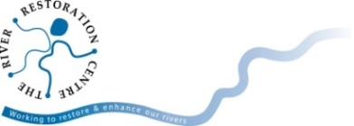
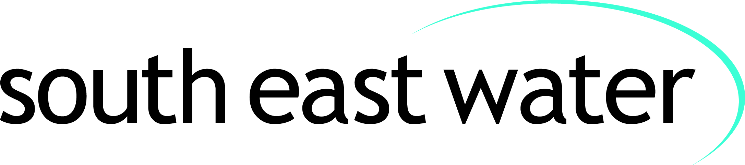
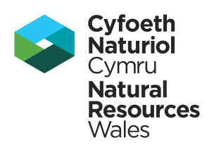
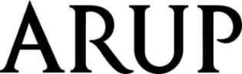
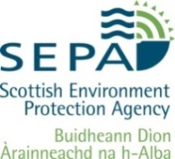
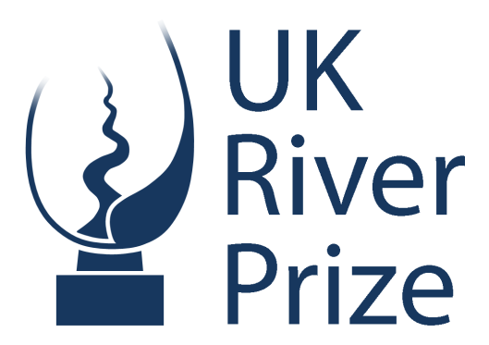
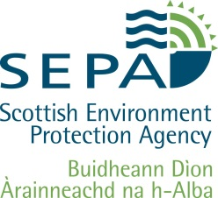
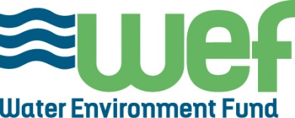
Finalists announced
for the 2018 UK River Prize
The UK River Prize celebrates the achievements of those individuals and organisations working to improve our rivers and catchments, and recognises the benefits to society of having a healthy natural environment.
After much deliberation the judges selected the four category winners below. These four winners will go forward as finalists in the competition. The overall 2018 UK River Prize winner will be presented with the Nigel Holmes Trophy.
The finalists for the 2018 UK River Prize are:
Finalist | Category | Lead applicant
Love Your River Telford  Shropshire | Innovation project  Demonstrating an innovative approach to protecting and improving the river environment | Environment Agency
Hills to Levels  Somerset | Catchment-scale project  Demonstrating an integrated catchment-wide approach to raising awareness and tackling river quality problems | Farming & Wildlife Advisory Group South West
Connswater Community Greenway  Belfast | Urban rivers project  Working on highly constrained and modified urban watercourses to improve biodiversity, flood protection, access and recreation | Connswater Community Greenway Trust
Tame Valley Wetlands Landscape Partnership  Warwickshire & Staffordshire | Multiple benefit partnership project Demonstrating a long-term partnership approach to restoring the ecology and natural functioning of rivers and wetlands | Warwickshire Wildlife Trust
Administered by the River Restoration Centre and judged by a panel of experts, the overall winner of the UK River Prize for 2018, and recipient of the Nigel Holmes Trophy, will be announced on the 24th April.

The announcement and presentation will take place at the UK River Prize awards dinner on the 24th April at the De Vere East Midlands Conference Centre, in conjunction with the River Restoration Centre’s Annual Network Conference which attracts over 300 delegates.
“The 2018 UK River Prize has attracted an exceptional and diverse group of projects from far afield and demonstrates how much passion, commitment and effort goes into restoring the health and quality of our rivers.
The standard of work carried out by local partnerships, charities, volunteers and agencies, in managing their river for people and wildlife, is exceptionally high.
Each of the four finalists had to really justify their place as a category winner. I would like to thank all of the applicants who submitted their projects for consideration.”
Martin Janes, Managing Director, River Restoration Centre

“Arup is once again delighted to partner The UK River Prize in 2018. We champion best practice, innovation and pragmatic thinking, and we fully support the recognition that this prestigious award provides. Following on from last year’s inspiring finalists, it is superb to see another great set of deserving projects shortlisted this year.”
Mark Fletcher, Global Water Leader, Arup
“We’re delighted to be associated with this high profile national award. The impressive level of entries submitted for the 2018 UK River Prize reflect our ambition of restoring, maintaining and improving our rivers, catchments and the natural environment. South East Water is fully committed to supporting excellence and best practice in water management, which has clearly been demonstrated through the projects submitted by this year’s innovative and creative finalists.”
Simon Lohrey, NEP Surface Water Catchment Management Lead, South East Water
Notes to editors
The overall winner will be announced at the River Restoration Centre Annual Network Conference UK River Prize Awards Dinner to be held at the De Vere East Midlands Conference Centre on the 24th April 2018.
Short videos will be submitted by all four finalists. These will be available to view on the River Restoration Centre’s website prior to the announcement on the 24th April 2018.

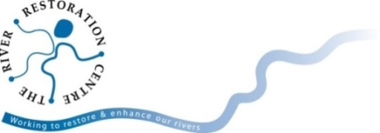
All media enquiries
Joshua Robins, River Restoration Centre
Josh@theRRC.co.uk
01234 752979
Further information is available at http://www.theRRC.co.uk/uk-river-prize

