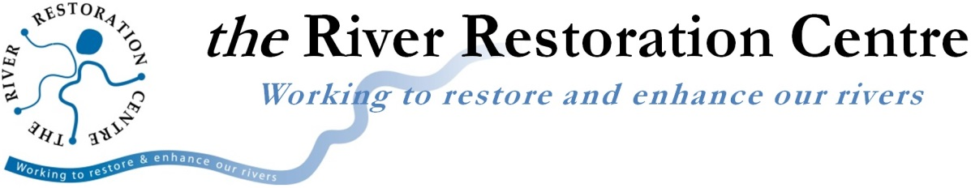

River Champions

The success of projects aiming to improve rivers for wildlife and people is largely influenced by the involvement of volunteers. The River Restoration Centre understands the importance of this contribution and wishes to acknowledge those that may otherwise not get recognition.

‘River Champions’ seeks to celebrate the outstanding efforts of individuals contributing to river restoration in their area. It aims to recognise those dedicating time outside of their day-to-day roles to contribute toward improving rivers for wildlife and people. The selected River Champions will be recognised in the following ways:
- Receive a River Champions Certificate from the River Restoration Centre.
- Mentioned at the UK River Prize Awards Dinner on the 4th April 2017.
- Individually acknowledged on the River Restoration Centre’s social media platforms.
- Individually featured in the River Restoration Centre’s Bulletin which is sent out to over 2,900 contacts from across the UK and Europe.
- Documented on the River Restoration Centre’s website where their contribution and achievements will be detailed on a permanent River Champions webpage.
- Presented on a ‘2017 River Champions’ poster in the Poster Session at the 2017 River Restoration Centre’s Annual Network Conference from the 4th - 5th April.

Below is a brief application form detailing contact information for the proposer and nominee and a short summary of the nominee. Please submit this form and attach a photo of the nominee (mug-shot or an action photo!) to champions@therrc.co.uk by Monday 6th March 2017.

*RRC suggests that the nominee should not be made aware of the nomination. This will create an element of surprise and will also mean that RRC can provide you with feedback on the nomination without the nominee knowing.

Terms and conditions
- You give permission for the River Restoration Centre to use the information submitted for promotional or other non-commercial use.
- The ‘River Champions’ will be chosen based on each nominee’s level of involvement, long term commitment, impact and achievements.
- RRC will contact the River Champions if they are selected to inform them of their nomination and gain consent for promotional material.
- If the nominee is not selected as a River Champion, RRC will contact the proposer to provide feedback on the nomination.

Do you agree to the terms and conditions? ☐
Is the nominee aware they are being nominated? ☐
Are you happy for us to contact you should we require more information? ☐

Web: www.therrc.co.uk Email: rrc@therrc.co.uk Tel: 01234 752979
Nomination form

Your name and organisation: Click here to enter text.
Your contact details: Click here to enter text.

Nominee information:
Name: Click here to enter text.
Contact details: Click here to enter text.
Day job: Click here to enter text.
How long have they been giving up their time to improve rivers?
Click here to enter text.
Please describe how much of their available time they dedicate to voluntary river work:
Click here to enter text.

Click here to enter text.

Involvement – What motivated them to get involved in river restoration? What have they been involved in (projects, initiatives, events etc.)? What roles do they take on in the work they do?
Short paragraph (max. 150 words)
Click here to enter text.

Contribution to organisations capacity and/or delivery of projects – What has been achieved that would not have been possible without this individual's contribution?
Short paragraph (max. 150 words)
Click here to enter text.

Why should this person be considered as a River Champion? For example, do they have an ability to lead, motivate, inspire and engage? Do they have a consistent will to go out of their way to help others to successfully deliver a project? Have they demonstrated a long term commitment to improving rivers?
Short paragraph (max. 150 words)
Click here to enter text.

Please send your completed nomination form and photo of the nominee to Champions@therrc.co.uk

You should receive confirmation of your nomination within 48 hours of your submission. Please contact us if you do not receive confirmation.

The River Champions will be announced at the end of March.
Web: www.therrc.co.uk Email: rrc@therrc.co.uk Tel: 01234 752979

